

**Advanced Software Engineering**

Course # CSEE 5551 00001

Semester: Spring 2017

LAB Assignment # 2

Submission Date: 2/1/2017

Student Name: Satya Sai Deepthi Katta

Student ID: 16231371

**Instructor:** Yugyung Lee

**Email:** LeeYu@umkc.edu

**Department of Computer Science & Electrical Engineering**

**University of Missouri, Kansas City**

***Create Wireframes and a Web Application with at least 3 Pages***

**Task 1:**

Create Wireframes for Website Pages.

**Task 2:**

Create 3 Web Pages.

* Registration Page to create a Account for a User.
* Login Page to get User Credentials.
* Home Page created with Google API’s to get Directions and Weather between two Cities.

**Task 3:**

Check the Quality of Code using JSLint.

**Task 4:**

Create Repository in GitHub.

* Source is dumped into the Source code folder.
* Screenshots are given in Documentation folder.
* Detailed Report of the Assignment is given in Wiki Page.

Wireframes are created using Creately.com using the wireframes & UI mockups. The wireframes include Login page, Registration page and the Home page for the website.

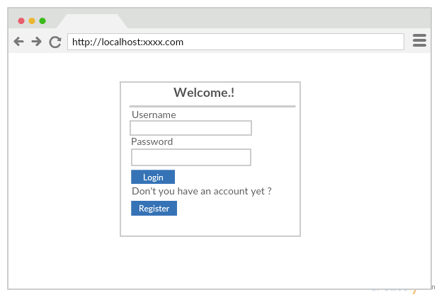

Fig 1. Wireframe for the Login Page of the Website.

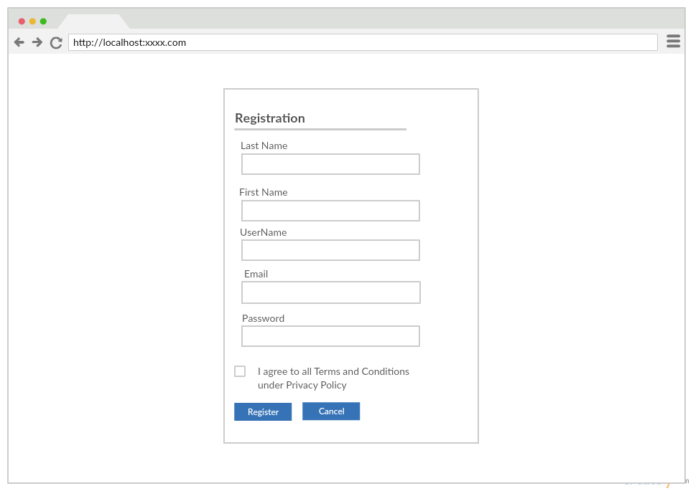

Fig 2. Wireframe for Registration Page of the Website.

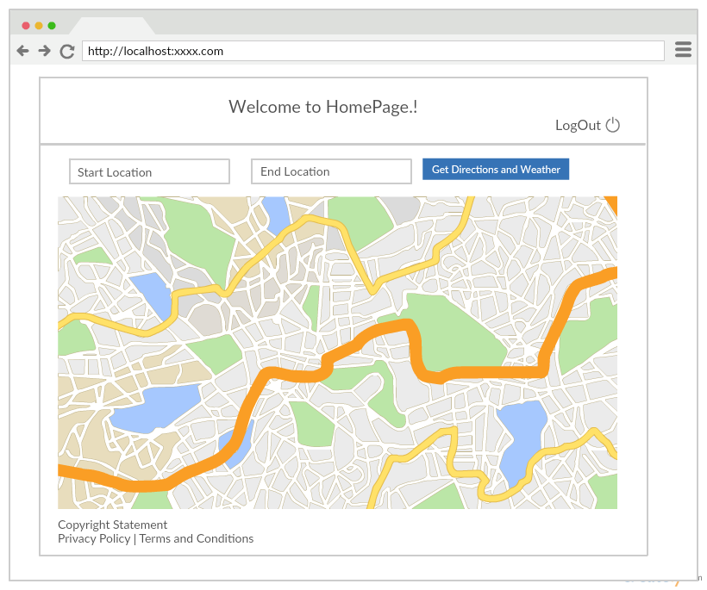

Fig 3. Wireframe for Home Page of the Website.

**TASK 2:**

Webpages are created for Login Page, Registration Page and Home Page using the Webstrom Software. For each page .html, .js and .css files are created.

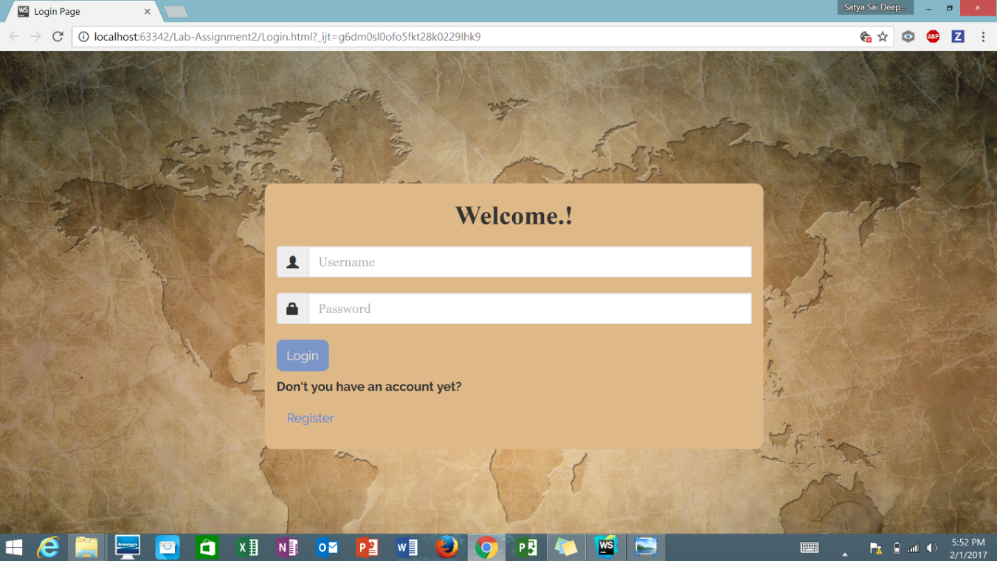

Fig 4. Login Page of the Website.

When account doesn’t exist then clicking onto the Register button navigates to the Registration Page which takes the details of the User.

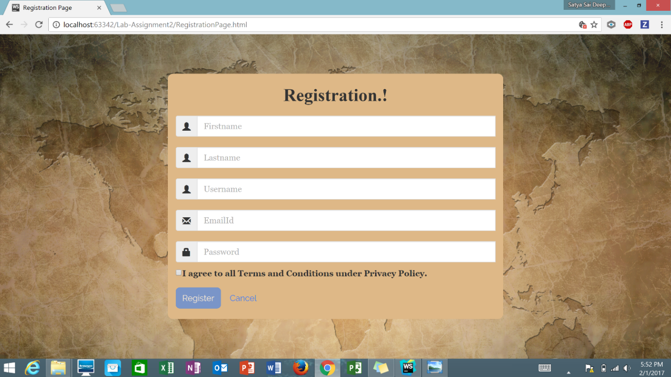

Fig 5. Registration Page of the Website.

When the account is created in the website then for getting the directions and weather, login details are entered in Login page.

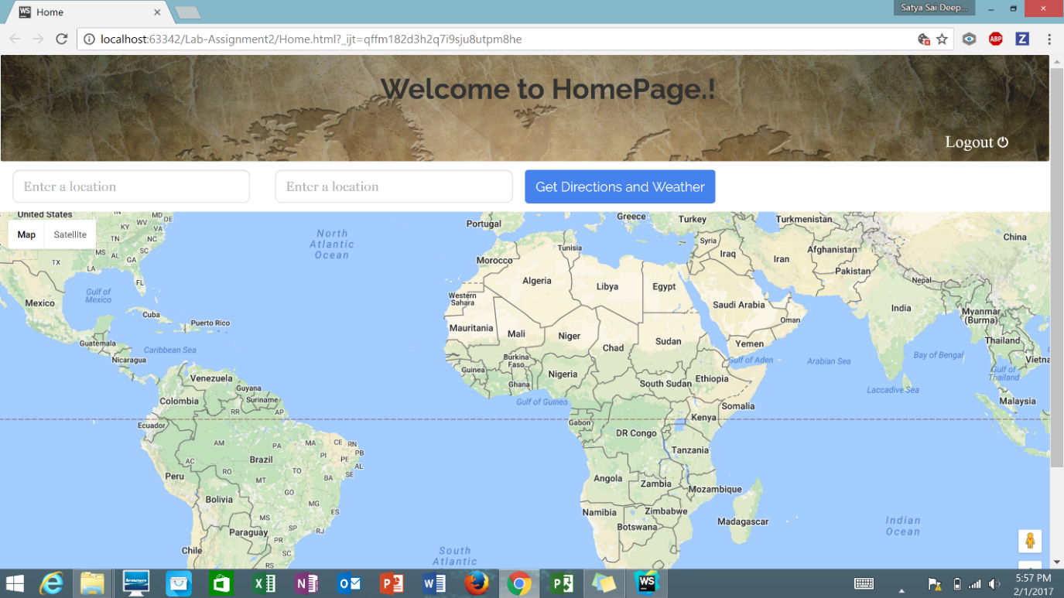

Fig 6. Home Page of the Website.

The account is created in the website as shown in the below.

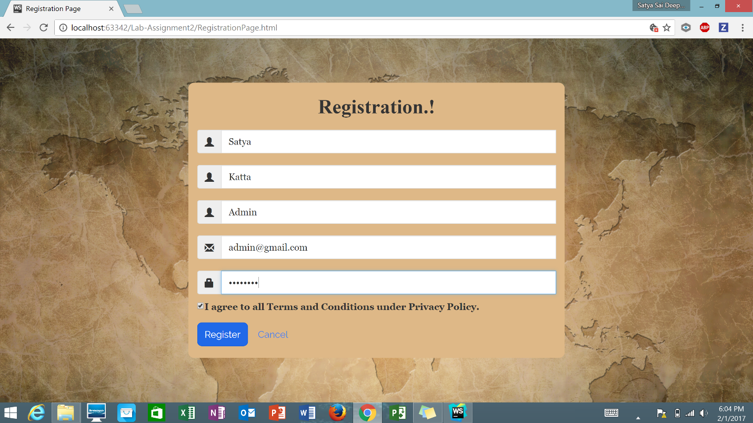

Fig 7. Registration page containing the User Details.

The registration confirmation is shown in the screenshot.

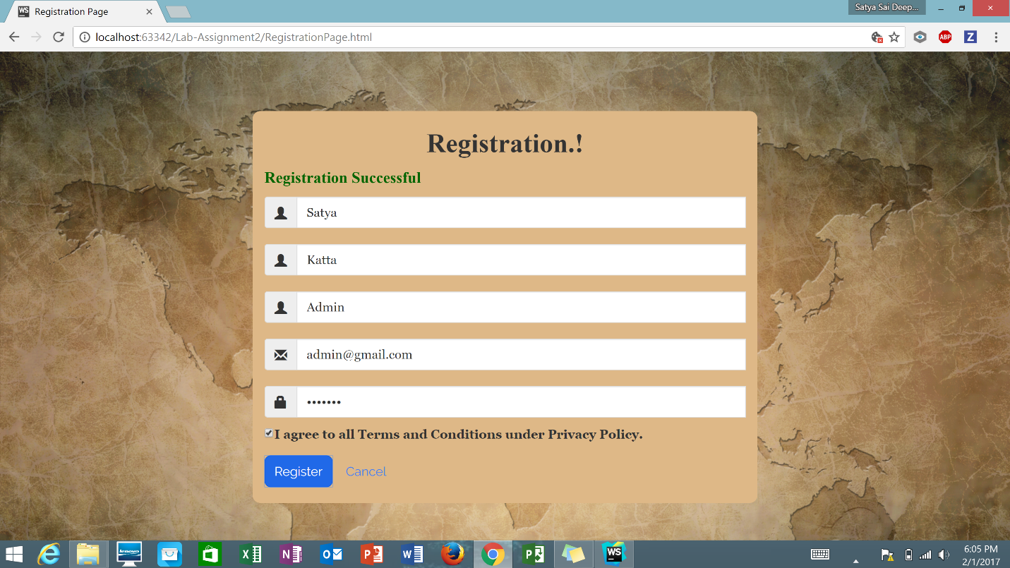

Fig 8. Confirmation Message about the Registration.

The user gives the credentials in the Login Page to enter into the Home Page for getting the details in the Maps.

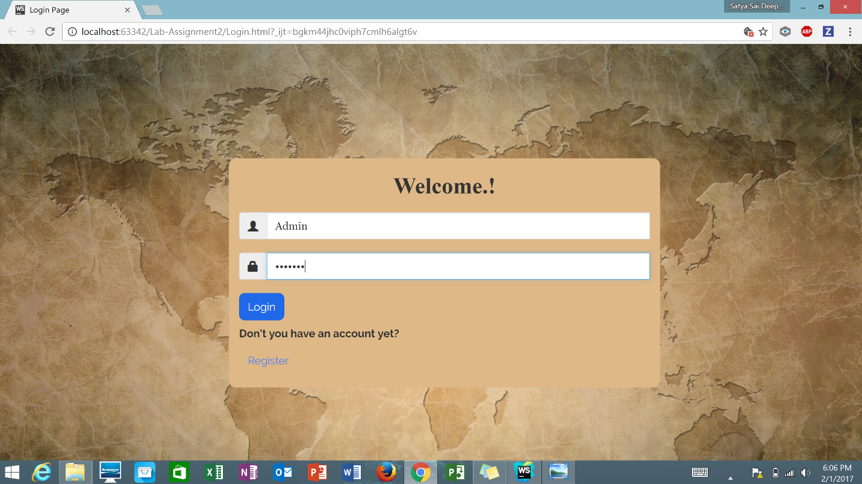

Fig 9. User credentials entered to Login.

The cities whose weather details needs to be determined are given in boxes available in the Website.

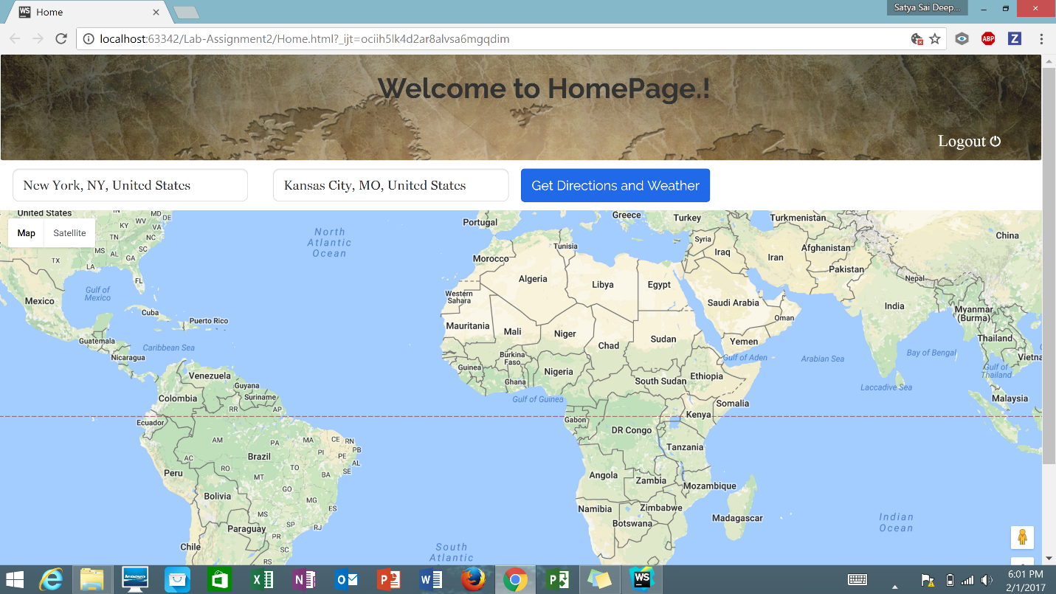

Fig 10. Source and Destinations states are entered.

Now Directions and Weather are given in the screenshot provided below.

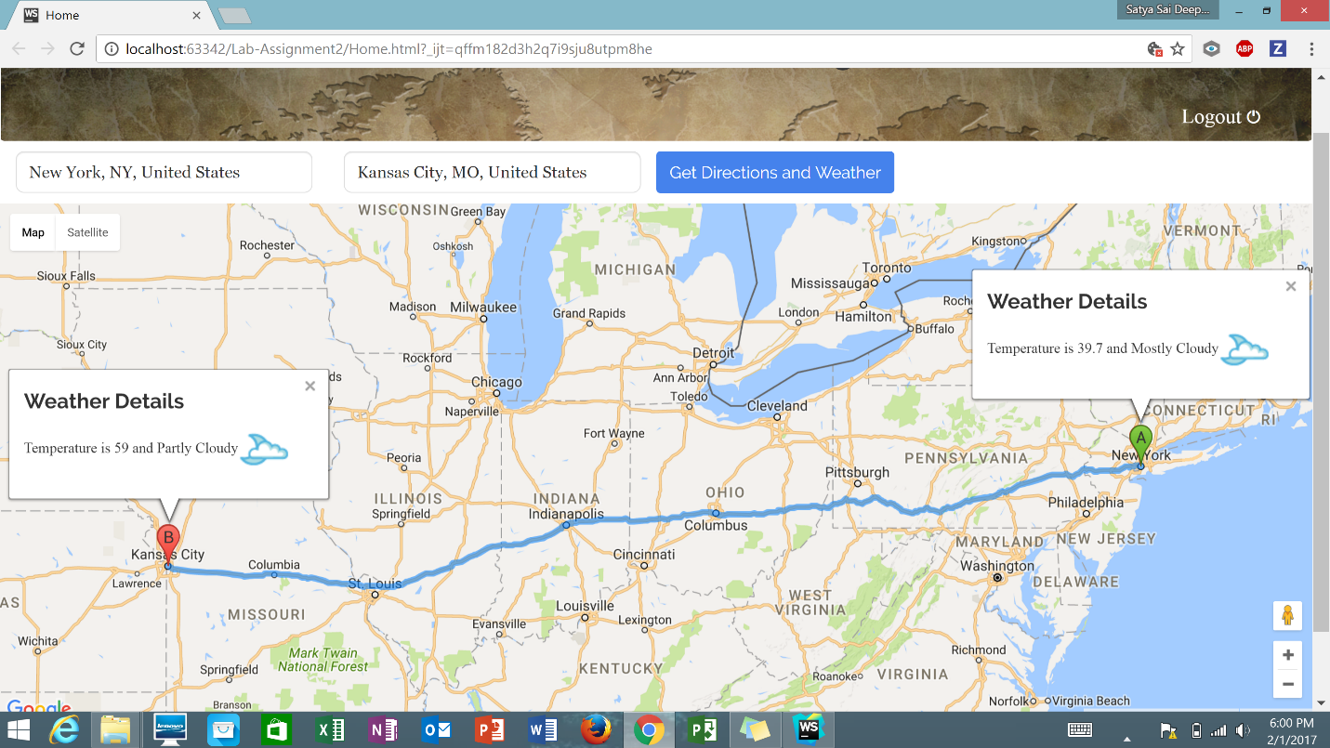

Fig 11. Details between the cities are Displayed in the Website.

**TASK 3:**

Java Script Codes are injected into JSLint website for analyzing the quality of the code. The screenshots are provided below.

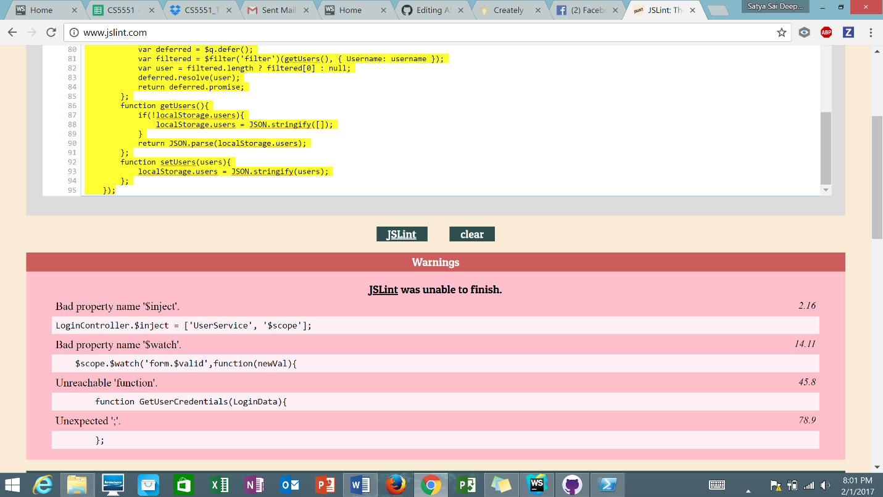

Fig 12. Warnings displayed for Login Page JavaScript in JSLint.

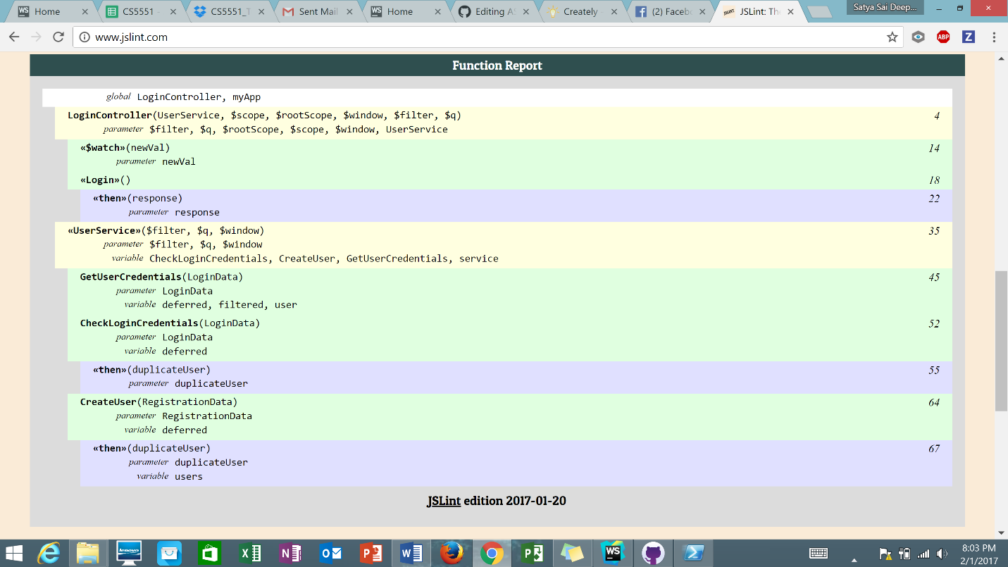

Fig 13. Function Report of the Login Page JavaScript of JSLint.

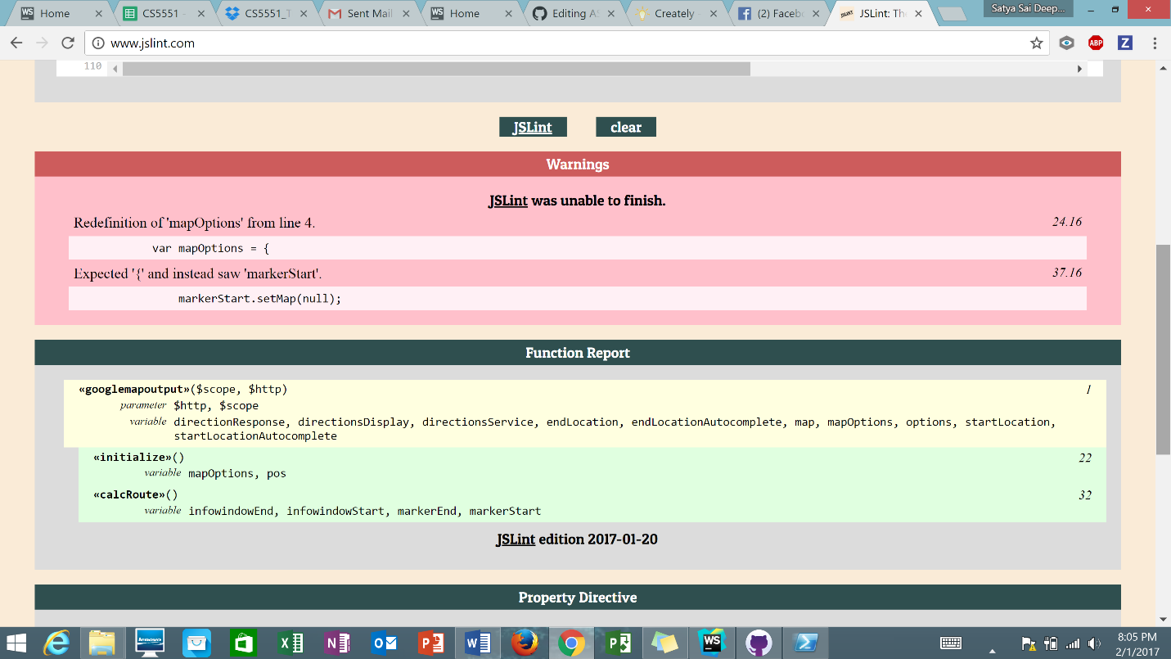Fig 14. Code Analysis of Home Page JavaScript code in JSLint.

**TASK 4:**

New repository is created in the GitHub.

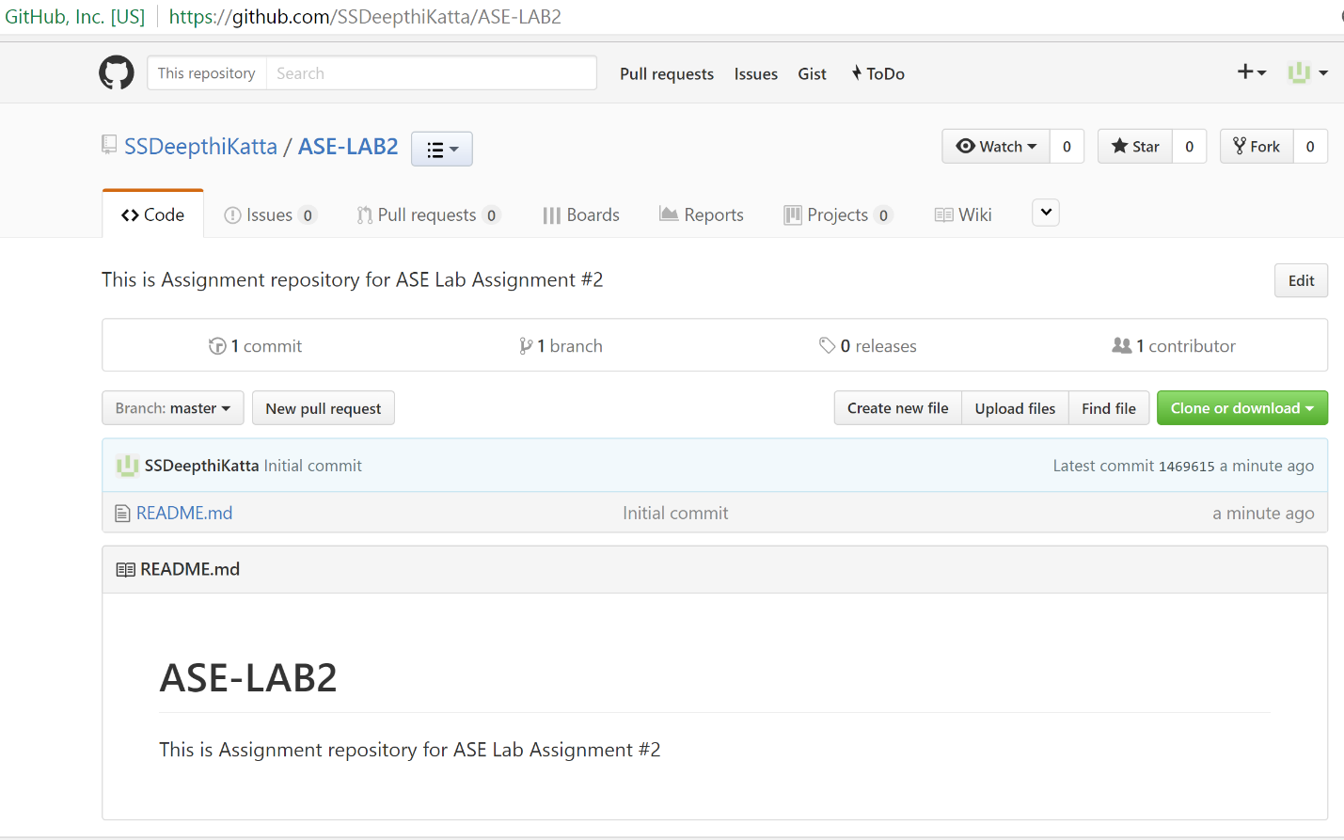

Fig 15. New Repository for Lab Assignment 2.